

**Application 2023**

**CBPATSISP Endorsed**:

*Best Practice Indigenous Governance- Commissioning and Partnering*

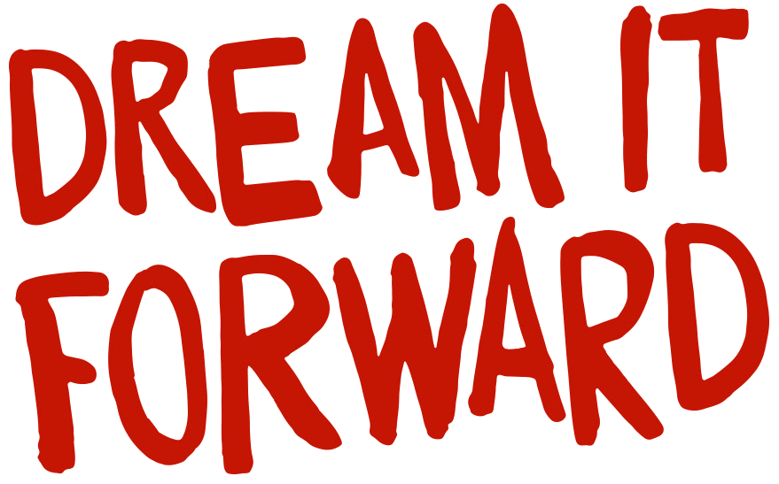

**APPLICATIONS CLOSE THURSDAY, 25 MAY 2023**

**APPLICANT DETAILS**

|  |
| --- |
| **NAME of Applicant/Community/Organisation/Service** |
| ABN (if applicable): |
| Postal Address:  Region: |
| **Name of Contact Person:** |
| Phone/s: |
| Email: |

**RESOURCES**

Are you currently funded by the Mental Health Commission?  **No  Yes**

Are you currently funded from any other source?

**No**  **Yes** If yes, please provide details below

Could this project go forward in any capacity without ***Dream it Forward*** funding?

**No**  **Yes** If yes, please provide details below

**GRANT REQUEST AND PROJECT DETAILS**

|  |  |
| --- | --- |
| 1. **COMMUNITY / ORGANISATION / SERVICE**  |  | | --- | | *Describe your community or organisation or service as it is now -how many people are involved; what social and emotional wellbeing (SEWB) activities/support are provided.*  *Are other organisations involved in this project?*  **No  Yes** If yes, please include a letter or e-mail of support | |

|  |  |  |  |  |
| --- | --- | --- | --- | --- |
| **2. YOUR PROJECT**   |  | | --- | | 1. *Projects must respect key elements of social and emotional wellbeing, and the funding criteria referenced in the Guidelines. Identify which criteria this project will address (****click one or more below****)* | | *Focuses on hope and healing*  *Connection to country*  *Strengthens cultural identity*  *Involvement of Elders*  *Prevention of psychological distress*  *Strengths-focused*  *Addresses Intergenerational trauma and grief*  *Increases social connectedness, belonging and purpose*  *Strengthens individual, family, kinship and community wellbeing*  *Creates a positive environment that improves people’s awareness and access to services*  *and natural supports*  *Increases awareness about the project/service to the community and to other*  *organisations* | |  |  | | --- | | 1. ***Describe the proposed project.*** *What activities are planned? What items/services are requested? Include proposed dates for camps, daytrips, workshops if they are part of the project.* |      1. *Include the number of people you expect will participate in the project and some detail, example Elders, youth, facilitators, other service providers.* |

|  |  |
| --- | --- |
| **3. SOCIAL AND EMOTIONAL WELLBEING (SEWB) OUTCOMES**     |  | | --- | | 1. *Please identify clear project objectives and outcomes – what is the change you hope to see?* |   **B.** *Is the change sustainable?* |

|  |  |  |  |  |  |  |  |  |  |  |  |  |  |  |  |  |  |  |  |  |  |  |  |  |  |  |  |  |  |  |  |  |  |  |  |  |  |  |  |  |  |  |  |  |  |  |  |  |  |  |  |  |  |  |  |
| --- | --- | --- | --- | --- | --- | --- | --- | --- | --- | --- | --- | --- | --- | --- | --- | --- | --- | --- | --- | --- | --- | --- | --- | --- | --- | --- | --- | --- | --- | --- | --- | --- | --- | --- | --- | --- | --- | --- | --- | --- | --- | --- | --- | --- | --- | --- | --- | --- | --- | --- | --- | --- | --- | --- | --- |
| **4. PROJECT BUDGET**  **Section A is the amount being requested in this application.**  Please make your project budget detailed, specific, and transparent and accompanied by quotes where possible. Do not round up totals - state real expected costs.  Do not include GST in the budget. GST will be paid separate and apart from the grant.   |  |  | | --- | --- | |  |  | | 1. Detailed Expenses requested from DIF grant   (do not include GST) | **Grant Request** | |  |  | |  |  | |  |  | |  |  | |  |  | |  |  | |  |  | |  |  | |  |  | |  |  | |  |  | | 1. Total Dream it Forward Grant Request (do not include GST) |  | |  |  | | 1. Please list any other income received in support of the project from other sources (if relevant) | Other Income | |  |  | |  |  | |  |  | |  |  | |  |  | |  |  | | 1. Total Other Income |  | |  |  | | Please list any In-Kind project support – unpaid voluntary contribution of goods and services (if relevant) | |  | |  | |  | |  | |  | |  | |

**5 GRANT AGREEMENT – DECLARATION**

***If a Grant is provided, the Applicant agrees to the following conditions:***

1. That the impact of the grant will benefit the Applicant’s group members in line with the positive social and emotional wellbeing outcomes listed in section 2 of this document.

2. ConnectGroups will be the brokering body responsible for approving the grant, liaising with suppliers and successful Applicants, overseeing the purchase of requested items/services and ensuring the timely receipt of the approved items/services to the successful Applicant. This way, accountability for grants will be the responsibility of ConnectGroups and will include the provision of documentation, including copies of invoices and a summary statement of all expenses to be provided to the Mental Health Commission.

3. The Applicant in receipt of the grant will retain a copy of all receipts, warranties and service agreements and become responsible for maintaining these after handover of goods and/or services.

4. If there is to be any delay in the expenditure of the grant, a written request will be made seeking approval for an extension of time. Ideally, funds are to be expended within the designated period.

5. All conditions specified in the grant submission which have been approved will need to be met.

6. The Applicant will be advised promptly of any changes/adjustments that need to be made, recommendations of alternative products or services and any other related and/or unexpected changes.

8. In signing this declaration, the signatory is verifying that they understand the parameters of the ‘Dream it Forward program’ and acknowledge ConnectGroups as the primary broker, responsible for the dissemination of funds. No cash requests for money grants will be approved, nor will requests for monies to be directly debited into a group or person’s account.

I (name of authorised Applicant), agree to the parameters set out by ‘The Dream it Forward Program’ Grant Agreement and wish to submit this grant application on behalf of (name of Project/Service)

Authorised Applicant (signature), Date _______________

Witness (print name), _______________

Witness (signature), Date _______________

**How to Apply**

**APPLICATIONS CLOSE THURSDAY, 5 MAY 2023**

Complete the Grant Application form and submit to:

**EMAIL** [karen@connectgroups.org.au](mailto:karen@connectgroups.org.au)

OR

**POST ConnectGroups Support Groups Association WA**

Dream It Forward Program

PO Box 1209

Booragoon, WA 6954